William Selbie

[selbiew@oregonstate.edu](mailto:selbiew@oregonstate.edu)

Final Project – Ocean / Wave Simulation

Link: https://media.oregonstate.edu/media/t/0_knflfs6a

Description:

The project starts with a shape (I recommend using a sphere for viewing waves and ripples and a cylinder for just viewing waves). It then splits the shape into sand and water, wherein sand has a brown colour with an alpha value of 1, while water is blue and slightly transparent (alpha value less than 1). The user can where the ocean floor begins. Then the water itself is either wavy or ripply (determined by the uniform Boolean variable uIsWaves). If the water is wavy, then the user alter the amplitude and frequency of the waves, which use both noise and sin waves to derive their form. If the water is ripply (which cannot be view in the cylinder due to the topology of the object which prevents raising height in concentric circles), then the user can alter the ripple amplitude and frequency as well.

In order, the images are a cylinder with waves, a sphere with ripples, and a sphere with waves.

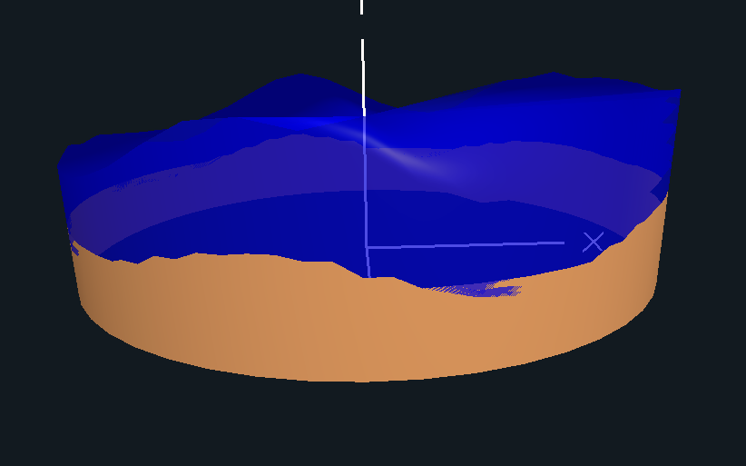A picture containing aircraft, balloon, transport

Description generated with very high confidenceA close up of a logo

Description generated with high confidence